TASK 3

Minikube Deployment Task

**Name**:VISHAL K K

**RollNo**:22CSR241

# Step 1: Start Minikube

Start the Minikube cluster using the following command: minikube start

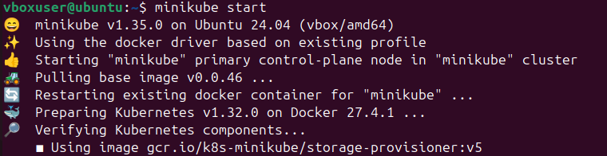

This initializes the Minikube cluster using Docker as the driver.

# Step 2: Install Kubectl

Since Kubectl is not found, install it with the following command:

sudo snap install kubectl --classic

Alternatively, you can download it using curl:

curl -LO "https://dl.k8s.io/release/$(curl -L -s

https://dl.k8s.io/release/stable.txt)/bin/linux/amd64/kubectl.sha256"

# Step 3: Verify Kubectl Installation

Check the client version to confirm successful installation:

kubectl version –client

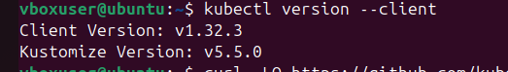

# Step 4: Create a Deployment

# 

Create a deployment : kubectl create deployment z --image=kkvishal/devops --port=80



# Step 5: Expose the Deployment

Expose the deployment as a NodePort service: kubectl expose deployment z --port=80 --type=NodePort



# Step 6: Verify the Pod

Check the running pods: kubectl get pods



# Step 7: Access the Service

# 

Expose the service using Minikube and get the URL:

minikube service pod1

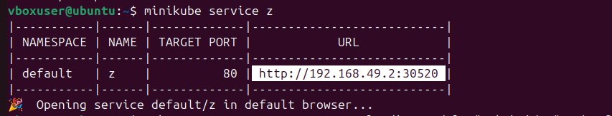

# Step 8: Output in the Web Browser

